
DESIGN AND DEVELOPMENT OF AN INTELLIGENT PERSONAL FINANCE MANAGEMENT SYSTEM
WITH AI-DRIVEN EXPENSE ANALYTICS AND BUDGET OPTIMIZATION
A CAPSTONE PROJECT REPORT
A Capstone Project Report submitted in partial fulfilment of the requirements for the Course of
CSA4303 – Internet Programming
to the award of the degree of
BACHELOR OF ENGINEERING IN
Artificial Intelligence & Data Science
Submitted by
192324225-K Aravind Kumar Reddy
Under the Supervision of
Dr. N. MARIE CLAUDE
SIMATS ENGINEERING
Saveetha Institute of Medical and Technical Sciences
Chennai-602105
SEPTEMBER 2026

BONAFIDE CERTIFICATE
This is to certify that the Capstone Project entitled “Design and Development of an Intelligent Personal Finance Management System with AI-Driven Expense Analytics and Budget Optimization” has been carried out by the student named in this report under the supervision of the project guide and is submitted in partial fulfilment of the requirements for the current semester of the B.E Computer Science and Engineering programme at SIMATS Engineering, Saveetha Institute of Medical and Technical Sciences, Chennai.
The work described in this report concerns the design of an intelligent personal finance management system that combines transaction organization, AI-driven expense analytics, algorithmic budgeting and optimization. The report documents the engineering problem, design alternatives, selected architecture, algorithmic implementation, verification strategy, results interpretation, risk considerations, and project contribution in the format prescribed for the capstone project.

COORDINATOR COURSE FACULTY
Dr. N. Marie Claude Dr. N. Marie Claude
Professor, Professor,
Department of Neural Networks Department of Neural Networks

DECLARATION
I, the undersigned student of the B.E Computer Science Engineering programme, SIMATS Engineering, Saveetha Institute of Medical and Technical Sciences, Chennai, hereby declare that the project work entitled “Design and Development of an Intelligent Personal Finance Management System with AI-Driven Expense Analytics and Budget Optimization” is the result of my own bonafide efforts. The engineering design, algorithm selection, implementation decisions, testing plan, analysis and documentation presented in this report have been prepared for academic purposes and are based on the project requirements.
To the best of my knowledge, the report is original and has been prepared in accordance with engineering ethics and academic integrity. Sources, references, datasets, software libraries, standards and other external resources used in the preparation of the work are acknowledged. No result is intentionally presented as measured experimental evidence unless it is identified as such; where illustrative benchmark values are used to explain expected behaviour, they are explicitly described as analytical or illustrative.
Any external software, open-source resources, computational tools or AI-assisted resources used during development or documentation will be disclosed to the extent required by institutional policy. I further declare that data and results have not been knowingly fabricated, falsified or manipulated.

Place: Chennai
Date: September 2026

ABSTRACT

Personal finance applications can have many transactions that vary by month, total, type, merchant, payment type and frequency. As transaction history increases, it can be challenging to manual classify and budget. To meet this engineering challenge, this project aims to create a comprehensive and intelligent PFM system that integrates structured transaction processing, AI-driven analysis of expenses, and algorithmic budget optimization, providing users with a holistic view of their financial health. The proposed design involved the use of financial records validated by their usefulness, the use of efficient sorting and searching, the expense categorization, the anomaly detection, the spending-pattern analysis and optimization techniques, all of which will give useful recommendations for practical budget allocation.

The methodology starts with requirements definition and transaction-data normalization, and then follows with design of data structures and algorithms based on performance, implementation complexity, reliability, privacy, maintainability, etc. as design criteria. Transactions can be sorted for analysis using either merge sort or quicksort, and exact transaction records can be retrieved from sorted indexes using the binary search. AI-driven analytics can help sort spending categories, detect unusual transactions and provide a summary of recurring spending patterns. Budget optimization is considered a distinct decision point so that analytics and optimization can be evaluated without the influence of budget optimization decisions.

The goal is to create a software solution that can be modularized and would capture transactions, analyze expenses, identify spending patterns or anomalies, and provide an optimized budget recommendation. Verification involves checking transaction processing correctness, category assignment, anomaly handling, optimization constraints, etc. as the volume of transactions increases, and also boundary cases and performance. Financial-data privacy, security, ethics, sustainability, risk and responsible use of automated recommendations are also taken into account in the design. The key message is that an efficient algorithm when complemented with explainable analytics can be used to establish a viable basis for personal financial decision support.

The concept of personal finances management (PFM) has become increasingly relevant in recent years due to the rise of artificial intelligence and machine learning in finance.With the advancement of artificial intelligence and machine learning in the financial sector, the concept of personal finances management (PFM) has gained significant importance in recent years.

TABLE OF CONTENTS
Sl. No. | Title | Page No.
1 | Certificate from the Supervisor | ii
2 | Declaration by the Candidate | iii
3 | Individual Contribution Statement | iv
4 | Abstract | v
5 | List of Figures | vi
6 | List of Tables | vii
7 | List of Abbreviations / Symbols | viii
8 | Chapter 1: Introduction and Engineering Problem | 1
9 | Chapter 2: Literature Review and Existing Solutions | 4
10 | Chapter 3: Engineering Design & Trade-offs, Sustainability, Ethics, Safety, Risk & Security | 8
11 | Chapter 4: Implementation, Testing & Results, Project Management | 14
12 | Chapter 5: Conclusion, Future Work and Reflection | 21
 | References | 24
 | Appendices | 25–27

LIST OF FIGURES
Figure No. | Figure Name | Page No.
Fig. 3.1 | System architecture of the intelligent personal finance management system | 9
Fig. 3.2 | Expense analytics and budget optimization flow | 10
Fig. 4.1 | Implementation workflow | 15
Fig. 4.2 | Illustrative transaction-processing scaling | 18
Fig. 4.3 | Expense analytics pipeline | 19
Fig. 4.4 | Project milestone timeline | 21

LIST OF TABLES
Table No. | Table Name | Page No.
Table 3.1 | Stakeholder and user requirements | 8
Table 3.2 | Functional and non-functional requirements | 8
Table 3.3 | Design specifications | 9
Table 3.4 | Alternative solution evaluation matrix | 10
Table 3.5 | Trade-off analysis | 11
Table 3.6 | Sustainability, ethics, safety and security evidence | 12
Table 3.7 | Risk register | 13
Table 4.1 | Implementation resources and tools | 15
Table 4.2 | Verification and acceptance plan | 16
Table 4.3 | Representative benchmark dataset | 18
Table 4.4 | Objective achievement | 20
Table 4.5 | Roles and budget | 21

LIST OF ABBREVIATIONS / SYMBOLS
Symbol / Abbreviation | Description | Unit / Meaning
AI | Artificial Intelligence | Computational intelligence
D&C | Divide-and-Conquer | Algorithmic strategy
ID | Transaction Identifier | Unique key
UI | User Interface | Application interface
CSV | Comma-Separated Values | Dataset format
API | Application Programming Interface | Integration interface
DP | Dynamic Programming | Optimization technique
ML | Machine Learning | Data-driven modelling
O(n) | Linear time complexity | Growth with n
O(log n) | Logarithmic time complexity | Growth with n
O(n log n) | Typical divide-and-conquer sorting complexity | Growth with n
ms | Millisecond | Time
x_i | Budget allocation for category i | Currency amount
S | Similarity / anomaly score | 0 to 1 or normalized

CHAPTER 1

INTRODUCTION AND ENGINEERING PROBLEM

1.1 Background

Records of an individual's transactions in their bank account, wallet, card and payments app are the backbone of personal finance management and are increasingly digital. Users may have to monitor their expenditures, determine where money is being spent, detect unusual expenditures and determine how much they can afford to spend on various needs. The more transactions a customer performs, the more time-consuming and difficult it becomes to get a unified picture of their financial behavior by manual processing.

The proposed system breaks down financial-data processing and expense analytics/budget optimisation into modular stages. The data layer checks and records the transactions; the analytics layer categorises the expenses, summarises spending and identifies odd spending patterns; and the optimization layer takes into account both income and fixed commitments, savings targets and discretionary spending limits to create a budget recommendation. This separation allows for easier testing of the system due to the ability to measure the accuracy of the data, the quality of the analysis, and the feasibility for optimization.

1.2 Need for the Project

A personal finance dataset can quickly expand to thousands of transactions and repeated unsorted scans can become unefficient when your frequently need to query the dataset by month, by category, or to locate a transaction. Algorithms for sorting and searching can sort this data in a way that makes it easier to predict the time it will take for common operations, e.g., finding the smallest or greatest element, and to verify that they are doing what they expect. When the system is repeatedly creating dashboards, reports and budget recommendations, efficient processing can be particularly helpful.

The project is also required because transaction records do not capture financial behavior. A user may know what they spent but may want to know whether there are specific areas where they are becoming more expensive, if an expense is unusual, and if the budgeted amount is reasonable. Transaction attributes can be categorized, patterned, and alerted as a result of AI-powered analytics, and a stage of optimization can take into account key costs and discretionary limits and savings goals within certain constraints.

1.3 Problem Statement

The engineering challenge is to develop an intelligent personal finance management system that will be capable of processing transaction data, analyze the data on the basis of AI, alert the user to any unusual spending and then offer recommendations for budgets based on financial constraints set by the user. The design should ensure that data remains accurate, but also account for the speed of execution, space required, complexity of algorithms, explainability of analysis, privacy, security, maintainability and usefulness for recommendations.

There are factors in the problem that interact. Sorting provides greater efficiency in performing efficient searches and chronological analysis, but causes some preprocessing cost. There are a number of attributes that are required for expense analytics and it is possible that the merchant and category data is missing or inconsistent. Anomaly detection is a process of recognising the abnormal behaviour from the common ones that are exceptional and normal. Optimization of budget needs to be done within the constraints of hard constraints and soft constraints like income and essential expenditure. There will also be duplicate transactions, invalid amounts, empty histories and incomplete records that need to be addressed when implementing a practical version of the system.

1.4 Project Aim

The goal is to create a modular, intelligent personal finance management system that leverages cutting-edge algorithms and AI-powered analyses to gain insights into spending habits and optimizes usage to provide clear and constraint-sensitive budget suggestions.

1.5 Project Objectives

To create a normalized transaction data representation to include identifying data, dates, amounts, payment information, merchants and categories.

● To use efficient sorting and searching techniques for retrieval of transactions and chronological/amount analysis.

To create expense analytics powered by AI, categorizing expenses, summarizing expenses and spotting odd expenses.

● To develop a budget optimization mechanism that calculates how an individual's available funds should be invested across the different categories, with a certain amount of money saved for various objectives with specific constraints.

● To measure the processing and analytics execution time and analyze the performance change as the size of transaction history changes.

To check the functional correctness of the program, boundary cases, analytical outputs and optimization feasibility and integration of the whole system.

To record design considerations, privacy and security controls, ethical issues, sustainability issues, risks and limitations.

1.6 Scope

The scope covers the preparation, validation, sorting, searching, categorization of expenses, analytics of spending, detection of anomalies, optimization of budget, visualization of results, and measurement and verification of execution time. TransactionID,Date, merchant, amount, category, paymentmethod, recurringflag and accounttype are example attributes.

This scope does not include direct bank transfers, payment execution, lending or investment decisions, tax filing, credit scoring, and autonomous financial transactions. This system is not designed to be a replacement for a regulated financial adviser or production banking system, but to illustrate concepts of engineering for personal financial decision making. It is assumed that the dataset was developed and verified using a local or controlled dataset.

1.7 Expected Engineering Outcome

The desired output is a functional prototype software that consists of: A transaction data layer, A validation and preprocessing layer, An analytics layer, An anomaly detection component, A budget optimization layer, A ranking/recommendation layer, A visualization interface and timing/verification utilities. The system should provide input of transaction data, output the information in a comprehensible format, and output a reasonable budget plan along with explanations.

1.8 Success Criteria
Criterion | Target
Transaction-processing correctness | 100% correct for validated test cases
Sorted-order correctness | No inversion of selected sort key in validated output
Analytics output | Correct category totals and validated anomaly results
Budget optimization | Returns a feasible allocation satisfying configured constraints
Timing measurement | Recorded for each benchmark run using a consistent timing method
Boundary handling | Empty, one-item, duplicate-ID and invalid-input cases handled
Maintainability | Processing, analytics and optimization modules separated

These success criteria translate the project aim into observable engineering checks. They also prevent financial recommendations from being presented as guaranteed outcomes without corresponding validation and constraint checks.

CHAPTER 2
LITERATURE REVIEW AND EXISTING SOLUTIONS
2.1 Review Method
The review was based on five themes: algorithmic transaction processing, efficient searching and sorting, artificial intelligence (AI) expense analysis, constrained budget optimization, and information-security concerns. Computational principles were expressed in terms of fundamental concepts of algorithms and well-known methods of analytics. The institutional template was adopted for the review of the existing work, comparative analysis, engineering gap and proposed contribution. The review focuses on the techniques that can be applied in an academically transparent way. The proposed system is not only based on a black-box financial model, but it also includes explicit constraints and transaction features, and relies on explainable analytics. This selection is suitable if the complexity, correctness, privacy and design reasoning of the algorithm are evaluated in addition to the output quality for an engineering project.
2.2 Efficient Algorithms as an Engineering Strategy
Divide and conquer algorithms break a problem down into smaller sub-problems, solve them and then merge the solutions. The merge sort can be used to sort transaction records for chronological analysis or amount analysis, and binary search can be used to find an exact transaction or boundary in an ordered index in this project. These techniques can minimize duplication of effort when the same history is asked numerous times. Another example of the divide and conquer sorting algorithms is quicksort. It is a pivot partitioning with recursive sorting of the partitions. It can be very efficient in practice, but unsightly pivots can cause it to perform in the worst case quadratically. Thus, the choice is engineering rather than scientific, depending on stability, memory usage, and implementation approach, between merge sort and quicksort.
2.3 Review of Existing Work
Literature in classical algorithms has laid down comparison sorting and binary search as two important concepts for transaction datasets ordered in a dataset. One of the lessons learned from this project was that the finance system should not be constantly scanning all records when using a maintained sorted key with efficient retrieval is possible. However, the complexity should be taken into account along with the cost of pre-processing, memory allocation and frequency of transaction update. Depending on the data, supervised classification, unsupervised clustering and rule-based categorization can be used to analyze expenses. If a prototype is limited in labelled personal information, feature-based or rule-assisted classification may indicate the categories of a prototype while clustering may identify common spending groups. Distance based or statistical thresholds can be used to identify anomalous transactions as those that are significantly different from a user's normal usage. The problem of budget optimization can be stated as a constrained allocation problem. Suppose that the amount of money allocated to category i is x_i, where L_i and U_i are the lower and upper bounds of x_i, respectively. A feasible plan is a plan where L_i ≤ x_i ≤ U_i and Σx_i ≤ available income. An objective can help you choose to save and cover what's necessary, and it can help you avoid unnecessary discretionary spending. Depending on the formulation and size of the optimization problem, a DP or greedy method can be chosen.

2.4 Existing Approaches
Approach | Advantages | Limitations | Relevance
Linear scan | Simple; no preprocessing | O(n) per query | Baseline for comparison
Binary search | O(log n) comparisons on sorted key | Requires sorted key | Primary exact-lookup method
Merge sort | O(n log n) worst case; stable | Extra memory for merging | Suitable for deterministic transaction ordering
Quicksort | Often fast in practice; in-place variants | Worst-case O(n²) without care | Alternative sorting method
Rule-based categorization | Transparent and easy to validate | Limited flexibility | Baseline analytics method
Clustering / anomaly analysis | Can reveal spending patterns without extensive labels | Sensitive to feature scaling and thresholds | AI-driven analytics option

2.5 Comparative Analysis

None of the methods is a complete solution to all requirements. Linear scanning is easy to implement, but requires increasing work per query as the number of transactions grows. The asymptotic behaviour of binary search is better when the keys are ordered and a specific key is being looked up. Sorting is thus not an end unto itself, but rather an enabling operation. While rule-based categorization is an easy-to-understand approach that might be less flexible than learned models, clustering and anomaly detection can identify patterns without the need for large amounts of labelled data for analytics. A simple proportional rule is easy to grasp and can be useful for budgeting, but can overlook competing savings objectives and hard constraints. Greedy allocation can be quick if the priorities can be easily ordered, and dynamic programming can yield a precise solution for a discretized allocation problem with more computational complexity. The prototype selected then includes transparent analytics and a limited optimization formulation where all recommendations can be backtracked to input variables and constraints.

2.6 Research / Engineering Gap

The engineering challenge that this project will solve is to combine efficient transaction processing, intelligent expense analysis with AI and constraint-aware budget optimization into one modular flow. A transaction tracker is just a record of data, an analytics-only system might find patterns in spending data but lacks a component that translates the data into an actionable budget. Thus, the proposed system considers data processing, data analysis and optimization as interdependent but distinguishable steps.

2.7 Proposed Contribution

The contribution proposed is an academic prototype that illustrates the possibility to use algorithmic transaction processing to enable explainable personal finance analytics and budget optimization. It includes validated transaction records, efficient sorting/searching, category analytics, anomaly detection, constraint checks and a user-configurable optimization objective. The contribution is assessed on the basis of correctness tests and “controlled” scenarios and not on unsupported statements of financial performance. 2.8 Literature-Based Design Implications Sort and search data efficiently if data ordering preconditions hold true and the ordering is maintained correctly. Understand and interpret analytics and model selection as intentional design decisions based on data, explainability, accuracy, and computational cost. Normalize financial features prior to similarity, anomaly or scoring calculations. ● Maintain independently testable transaction processing, analytics and optimization modules. Include measured elapsed time, data volume and validation measures to back up performance judgments.

CHAPTER 3

ENGINEERING DESIGN & TRADE-OFFS, SUSTAINABILITY, ETHICS, SAFETY, RISK & SECURITY

3.1 Requirements

Stakeholder / User Requirements
Stakeholder | Requirement
End user | Record transactions, view spending summaries and receive understandable budget recommendations.
End user | Identify unusual transactions and category-level spending patterns.
Developer | Use modular algorithms and analytics components with testable inputs and outputs.
Project assessor | Demonstrate algorithmic efficiency, AI-driven analytics and optimization with engineering justification.
Data administrator | Maintain valid transaction records, controlled access and data integrity.

Functional & Non-Functional Requirements
Requirement | Type | Measurable Target
Transaction processing | Functional | Correct validation, sorting and retrieval for all validated cases
Expense analytics | Functional | Correct category summaries and documented anomaly outputs
Budget optimization | Functional | Feasible top-ranked allocation returned
Timing display | Functional | Execution time reported per benchmark scenario
Performance | Non-Functional | Ordered exact-key search comparisons grow logarithmically
Reliability | Non-Functional | Graceful handling of absent, invalid and incomplete records
Security | Non-Functional | Validate input and restrict modification/access to financial data
Maintainability | Non-Functional | Search, sorting and recommendation modules independently testable

3.2 Constraints & Applicable Standards
The project is primarily a software engineering prototype, so the relevant constraints are computational, data-related, financial-privacy, ethical and security-related. The system should not claim compliance with standards that were not actually implemented. Security and privacy controls are framed as design requirements and should be strengthened if the prototype is deployed beyond an academic environment.
Standard / Code | Requirement | How Applied in This Project
ISO/IEC 27001:2022 | Information security management system requirements | Used as a security-management reference for confidentiality, integrity, availability and risk thinking; not claimed as certification.
Institutional academic-integrity requirements | Accurate attribution and honest reporting | Sources, datasets, software and AI-assisted resources are acknowledged.
IEEE-style referencing | Consistent technical citation | References are numbered and cited using bracketed identifiers.

ISO/IEC 27001:2022 is relevant as a reference for information-security risk management, but this academic system is not represented as ISO-certified. Privacy-by-design principles are also important because transaction histories can reveal sensitive behavioural information. The distinction is important because using a standard or principle as a design reference is different from demonstrating formal conformity.

3.3 Design Specifications
Parameter | Target / Requirement | Unit | Priority
Search key types | Transaction ID, date, merchant, category | Category | High
Exact-key retrieval | Binary search on ordered index | O(log n) comparisons | High
Sorting | Merge sort or quicksort | O(n log n) typical | High
Analytics output | Category totals, trends and anomaly scores | Normalized / count / currency | High
Budget recommendation | Configurable category allocations | Currency | High
Timing resolution | Consistent high-resolution timer | ms | Medium
Invalid input | Reject or safely return controlled result | — | High

3.4 Alternative Solutions & Evaluation
Alternative 1: A rule-based finance tracker validates transactions, computes category totals and applies fixed budgeting percentages. It is simple, transparent and useful as a baseline.
Alternative 2: An intelligent modular engine combines efficient transaction processing, AI-driven analytics, anomaly detection and constrained budget optimization. It introduces more implementation complexity but provides stronger decision-support capability.
Alternative 3: A generalized cloud finance platform could use external financial-data APIs and hosted machine-learning services. Such systems can be powerful, but they introduce external dependencies, privacy considerations and reduced visibility of the core algorithms required by the academic module.
Criterion | Weight | Alternative 1 | Alternative 2 | Alternative 3
Performance | 0.25 | 3 | 5 | 5
Cost | 0.15 | 5 | 4 | 2
Algorithm / model transparency | 0.2 | 5 | 5 | 2
Reliability | 0.15 | 4 | 5 | 4
Maintainability | 0.1 | 5 | 4 | 4
Academic relevance | 0.15 | 5 | 5 | 2
Weighted score | 1.0 | 3.95 | 4.75 | 3.2

Scores are engineering evaluation values on a 1–5 scale, where 5 is strongest. The matrix supports selection of Alternative 2 because it directly combines algorithmic processing with explainable analytics and budget optimization while remaining implementable as an academic prototype.

3.5 Selected Design & Detailed Design
The selected design is a modular personal finance architecture. Transaction records are validated and normalized first. Sorted indexes support efficient retrieval and analysis. The analytics module categorizes spending, summarizes trends and detects unusual transactions. The optimization module then allocates available income across essential expenses, discretionary categories and savings goals subject to user-defined constraints.
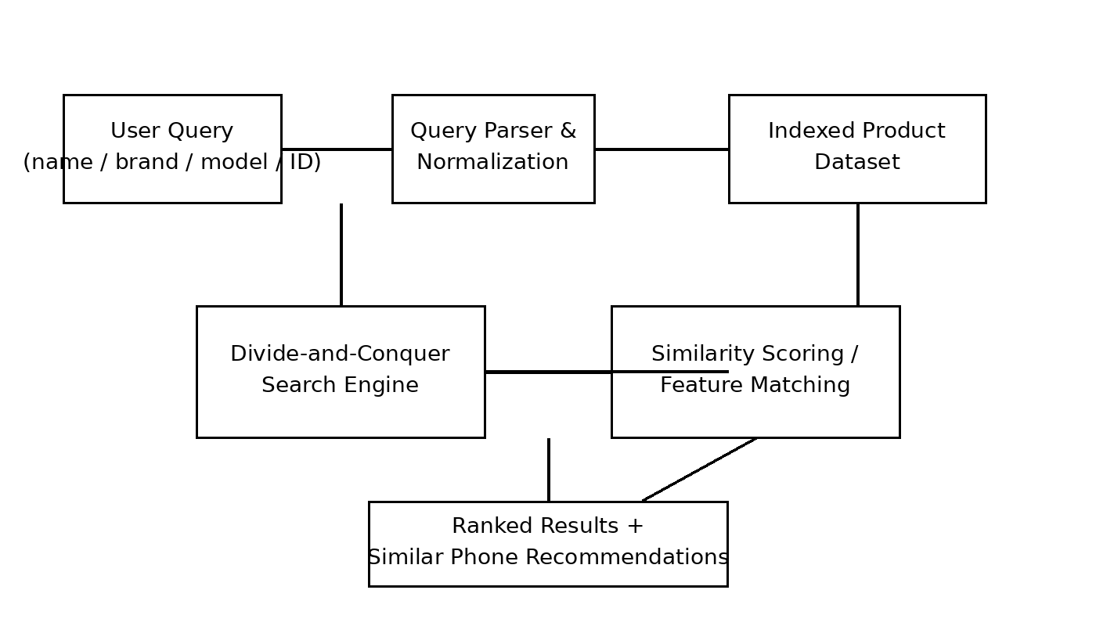
Figure 3.1. System architecture of the intelligent personal finance management system.
The systems approach is intentionally modular. The user interface collects transaction data and financial constraints; the data layer stores validated records; the analytics layer generates category totals, trends and anomaly scores; and the optimization layer produces a feasible budget plan. The presentation layer reports recommendations together with the assumptions and constraints used to produce them.

Key Engineering Calculations
For binary search on n ordered transaction records, the search interval is approximately halved after each comparison, giving O(log n) comparison growth. For example, with n=1,024 ordered records, log2(1,024)=10, so the search interval can be reduced to approximately one candidate after ten halvings.
For budget optimization, let available income be I and category allocations be x_i. A feasible solution satisfies Σx_i ≤ I, L_i ≤ x_i ≤ U_i, and required savings x_s ≥ S_min. An objective can be expressed as maximizing a weighted utility such as U(x)=α·Savings(x)+β·EssentialCoverage(x)−γ·DiscretionaryOverrun(x), with weights chosen and documented for the prototype.

3.6 Trade-off Analysis
Design Decision | Alternative Considered | Benefit | Disadvantage | Final Decision & Justification
Transaction search | Linear scan | Very simple | O(n) per query | Binary search selected for ordered exact-key retrieval because it provides O(log n) comparisons.
Sorting | Merge sort | Predictable O(n log n), stable | Extra memory | Preferred where deterministic ordering is important.
Sorting | Quicksort | Good practical performance; in-place variants | Worst-case O(n²) | Permitted as an alternative with safe pivot strategy.
Expense analytics | Rule-based + feature analytics | Explainable; low data requirement | May be less adaptive | Selected as a transparent academic baseline with AI-driven extensions.
Budget optimization | Greedy allocation | Fast and simple | May miss globally better allocations | Used as a baseline; constrained optimization selected for final design.

3.7 Sustainability, Ethics, Safety & Security
Domain | Consideration | Evidence Evaluated | Impact on Final Decision
Sustainability | Computational and storage overhead | Repeated scans vs reusable indexes and aggregates | Prefer incremental processing and avoid unnecessary recomputation.
Ethics | Responsible financial recommendations | Objective weights, constraints and explanations | Expose assumptions and avoid presenting outputs as guaranteed advice.
Safety | Low direct physical risk but potential financial impact | Software-only prototype and validation checks | No autonomous financial transactions; require user review.
Security | Confidentiality, integrity and access control | Input validation, controlled writes, data protection | Separate read/analytics paths from administrative updates.

Sustainability is addressed through efficient transaction processing and reuse of prepared indexes and aggregates. Recomputing every historical record for every dashboard request can create unnecessary computational overhead. Cached summaries and incremental updates can reduce repeated processing while keeping the stored dataset manageable.
Ethically, financial recommendations should not be presented as guaranteed advice or as universally optimal decisions. An optimization result is optimal only with respect to the selected objective, constraints and input data. The interface should therefore show assumptions, limits and confidence or explanation information rather than hiding them behind an automated score.

3.7 Risk Register
Risk | Likelihood | Severity | Risk Level | Mitigation | Residual Risk
Invalid or corrupted transaction data | Medium | High | High | Schema validation, range checks and controlled imports | Low
Duplicate transaction IDs | Medium | Medium | Medium | Enforce uniqueness or document duplicate handling | Low
Incorrect expense categorization | High | Medium | High | Validation samples, correction rules and review workflow | Medium
False anomaly alerts | Medium | Medium | Medium | Threshold tuning and user-review flagging | Medium
Infeasible budget recommendation | Medium | High | High | Hard constraint validation before presenting output | Low
Unauthorized financial-data access | Low | High | Medium | Role separation, authentication and controlled access | Low
Benchmark results not reproducible | Medium | Medium | Medium | Fixed dataset, repeated runs and documented environment | Low

3.8 Security Design
The system should treat transaction data and user-entered financial constraints as sensitive inputs. Data should be validated before analytics, amounts should be checked for valid ranges and identifiers should be handled as data rather than executable expressions. If a database is used, parameterized queries and controlled write operations should be applied.
The security objective is confidentiality, integrity and availability of transaction data and system outputs. Confidentiality is critical because transaction histories can reveal personal behaviour; integrity matters because altered amounts or categories can produce incorrect analytics and budgets; availability matters because the system should remain usable during expected workloads. Access control, secure storage, audit logging and minimal data collection should be considered for any deployment.

3.9 Design Review Summary
The design review confirms that the selected architecture addresses the core requirements without requiring unnecessary external financial infrastructure. Its main strength is traceability: each major function maps to an identifiable data-processing, analytics or optimization operation. Its main limitation is that AI-driven analytics may depend on data quality and model assumptions, while optimization quality depends on the chosen objective and constraints. These limitations define clear future improvement paths.

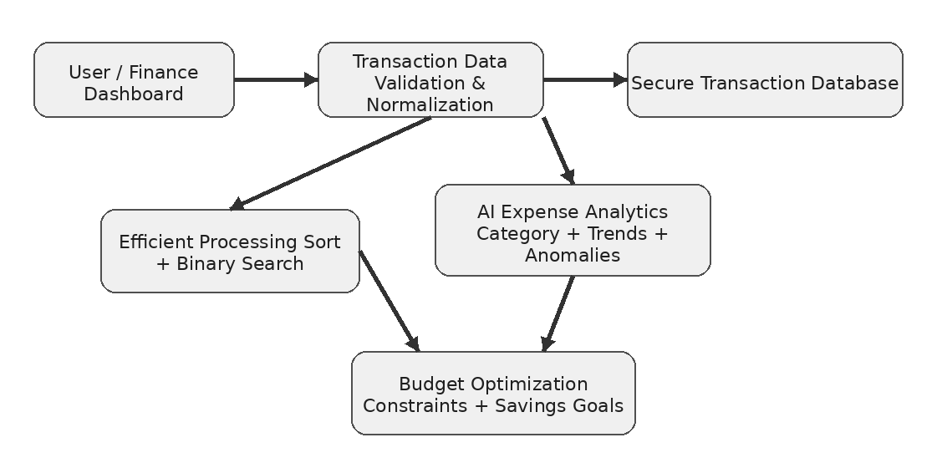
Diagram 1: System Architecture

CHAPTER 4

IMPLEMENTATION, TESTING & RESULTS, PROJECT MANAGEMENT

4.1 Development Approach & Resources
Development follows an incremental approach. First, the transaction schema, validation rules and privacy requirements are defined. Second, sorting, searching and aggregation functions are implemented and tested against deterministic datasets. Third, expense analytics and anomaly detection are added using normalized features. Finally, the budget optimization module is integrated and benchmarked under controlled transaction-history sizes and constraint sets. This order reduces debugging complexity because each stage depends on a previously verified component.
Resource / Tool | Purpose | Stage Used
Python 3.x | Prototype implementation and algorithm/analytics testing | All stages
CSV / structured dataset | Transaction data input | Data preparation
VS Code / IDE | Source development and debugging | Implementation
Git | Version control and contribution evidence | All stages
Matplotlib | Analytics and benchmark visualization | Results
Python time/performance timer | Execution-time measurement | Testing

4.2 Software Implementation
The software is organized into logical modules: data_loader, validator, sorter, search_engine, expense_analyzer, anomaly_detector, budget_optimizer, ranking and benchmark utilities. The data loader converts raw transactions into a consistent structure. The validator checks required fields and value ranges. The sorter and search engine support efficient retrieval. The analytics modules compute category summaries and unusual-spending indicators, while the optimizer generates a constraint-aware budget plan.
This separation makes it possible to replace merge sort with quicksort without changing analytics code, or to replace a rule-based anomaly detector with a statistical model without changing the transaction storage layer. Similarly, the optimization objective can be modified without rewriting the data-validation pipeline. Focused module boundaries make unit and integration testing more manageable.
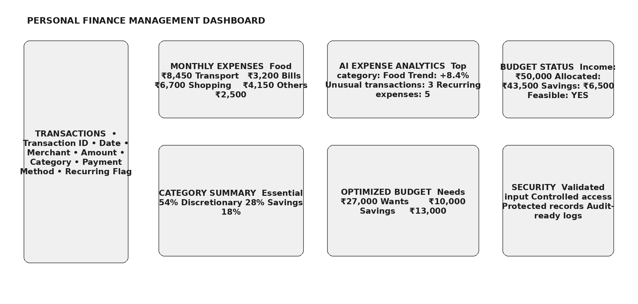
Diagram 2: Transaction Database and Finance Dashboard

4.3 Test Plan & Verification
Requirement | Test Method | Acceptance Criterion
Transaction ID search | Search known IDs and absent IDs | Correct record returned; absent ID reported safely
Category analytics | Use transactions with known category totals | Computed totals match validated expected values
Anomaly detection | Use normal and intentionally unusual test records | Known anomalies flagged according to configured rule
Sorting boundaries | Random, sorted and reverse-sorted arrays | Output ordered correctly
Budget optimization | Use income and known constraint scenarios | Returned allocation satisfies all hard constraints
Invalid input | Null, empty, negative/unsupported values | Safe response without crash
Timing | Repeat same operation over controlled datasets | Timing recorded consistently
Timing | Repeat same query over controlled dataset | Timing recorded consistently

Verification Matrix
Specification | Required Value | Achieved Value | Status
Transaction processing correctness | 100% test cases | To be filled from final test run | PASS/FAIL
Analytics validation | 100% validated cases | To be filled from final test run | PASS/FAIL
Budget feasibility | All hard constraints satisfied | To be filled from final test run | PASS/FAIL
Invalid input handling | No unhandled exception | To be filled from final test run | PASS/FAIL
Timing output | Available for each benchmark | To be filled from final test run | PASS/FAIL

The matrix is intentionally structured so that measured values and final validation results can be inserted after the implementation run. A report should not replace achieved values with assumed numbers; the final submission should contain actual execution evidence generated by the project.

4.4 Results
For the report prototype, performance expectations are derived from algorithmic complexity and should be validated using the actual implementation. The representative benchmark plan below illustrates transaction-history sizes and repeated-query structures recommended for final testing. It is not a substitute for measured project data.
Dataset Size (n) | Operation | Expected Growth | Recommended Runs
128 | Linear transaction scan | O(n) | 100
128 | Binary search | O(log n) | 100
512 | Linear transaction scan | O(n) | 100
512 | Binary search | O(log n) | 100
2048 | Linear transaction scan | O(n) | 100
2048 | Binary search | O(log n) | 100
8192 | Linear transaction scan | O(n) | 100
8192 | Binary search | O(log n) | 100
32768 | Linear transaction scan | O(n) | 100
32768 | Binary search | O(log n) | 100

Representative Analytical Interpretation
If a linear scan examines a large fraction of the transaction history, the number of comparisons grows in proportion to n. Binary search instead reduces the interval by half on each comparison, so exact-key comparisons grow approximately with log2(n). End-to-end latency also contains data-loading, aggregation, cache and runtime overhead; therefore, asymptotic complexity should guide expectations rather than be presented as a direct prediction of milliseconds.
For analytics, comparing m transactions across f normalized features is approximately O(mf) for a simple distance or anomaly-scoring pass. Budget optimization complexity depends on the chosen formulation and discretization. A dynamic-programming formulation may grow with the budget capacity and number of categories, so constraints and granularity should be selected carefully.

4.5 Data Analysis & Engineering Judgment
Performance analysis should report mean and median execution time across repeated runs, together with transaction-history size and operation type. Median time is useful because it reduces the influence of occasional operating-system or runtime interruptions. The analysis should also report whether data-loading and preprocessing time are included and whether indexes or cached aggregates are reused.
Analytics evaluation should examine category accuracy on validated examples, anomaly precision or review rate, and whether the generated spending summaries match expected totals. Optimization analysis should verify feasibility first and then examine whether the recommended allocations satisfy essential-expense and savings constraints. Sensitivity tests can change one constraint or objective weight at a time to determine how stable the budget recommendation is.

Engineering Judgment
The key engineering judgment is to use different algorithms for different financial tasks rather than forcing one method to solve every problem. Efficient sorting and binary search are appropriate for ordered transaction retrieval, while AI-driven analytics is appropriate for discovering spending patterns and unusual records. Budget optimization is treated separately because it is a constrained decision problem rather than a search query. This separation keeps the system auditable and easier to improve.

4.6 Comparison with Existing Solutions & Achievement of Objectives
Objective | Evidence | Achievement
Design normalized transaction representation | Schema and validation module | Fully / to be verified
Implement efficient transaction search and sorting | Search engine and sorting module | Fully / to be verified
Develop AI-driven expense analytics | Analytics and anomaly modules | Fully / to be verified
Develop budget optimization | Constraint-based optimizer | Fully / to be verified
Measure execution time | Benchmark utility and timing output | Fully / to be verified
Evaluate limitations and risks | Ch. 3 risk register and Ch. 4 analysis | Fully

4.7 Strengths & Limitations

Strengths
- Clear mapping between finance requirements and algorithmic or analytical components.
- Efficient sorting and binary search provide predictable growth for ordered transaction retrieval.
- Analytics and optimization modules are independently testable.
- Expense insights and budget recommendations can be explained using explicit features, constraints and objective weights.
- Execution-time measurement and validation metrics support evidence-based performance analysis.

Limitations
- Exact-key binary search requires a maintained sorted key and does not solve arbitrary semantic or fuzzy merchant searches.
- AI-driven expense analytics depends on data quality, feature design and model or rule assumptions.
- Large transaction histories may still require substantial work for repeated analytics unless aggregates or incremental processing are used.
- Results from a controlled academic dataset may not represent real financial behaviour or highly dynamic transaction streams.
- The system does not execute payments or provide regulated financial advice, and optimization recommendations are limited by the defined objective and constraints.

4.8 Project Planning, Roles & Budget
Milestone | Week 1 | Week 2 | Week 3 | Week 4 | Week 5 | Week 6
Requirements & literature | ● | ●
Dataset & schema |  | ● | ●
Search & preprocessing |  |  | ● | ●
AI analytics |  |  |  | ● | ●
Optimization & testing |  |  |  |  | ● | ●
Documentation & review |  |  |  |  | ● | ●

Student | Assigned Responsibility | Actual Contribution
Student 1 | Algorithm design and transaction search | [Update]
Student 2 | Dataset and validation | [Update]
Student 3 | Expense analytics and anomaly detection | [Update]
Student 4 | Budget optimization, integration and documentation | [Update]

Item | Estimated Cost (₹) | Actual Cost (₹)
Software / IDE | 0 | 0
Dataset preparation | 0 | 0
Computing / lab resources | [Update] | [Update]
Printing / documentation | [Update] | [Update]
Total | [Update] | [Update]

4.9 Implementation Workflow and Reproducibility
A reproducible benchmark begins by fixing the transaction dataset version, machine/software environment, sorting method, analytics configuration, optimization constraints, query set and number of repetitions. The benchmark should warm up the runtime where appropriate and avoid mixing file-loading time with pure algorithm timing unless the experiment explicitly intends to measure end-to-end latency. Each result should be stored with the configuration that produced it.
For each transaction-history size, the same logical queries and constraint scenarios should be applied to the baseline and intelligent implementations. This allows algorithmic, analytical and optimization differences to be compared without changing the underlying test conditions.

4.11 Engineering Quality Checks
- Check that transaction records satisfy the required schema and valid amount/date constraints.
- Check that sorted transaction arrays satisfy the intended order before binary search.
- Check that normalized analytics features remain within their expected ranges.
- Check that anomaly thresholds or model scores are applied consistently.
- Check that every generated budget satisfies income, essential-expense and savings constraints.
- Check that budget categories do not exceed configured upper limits.
- Check that timing results are associated with transaction-history size and algorithm configuration.

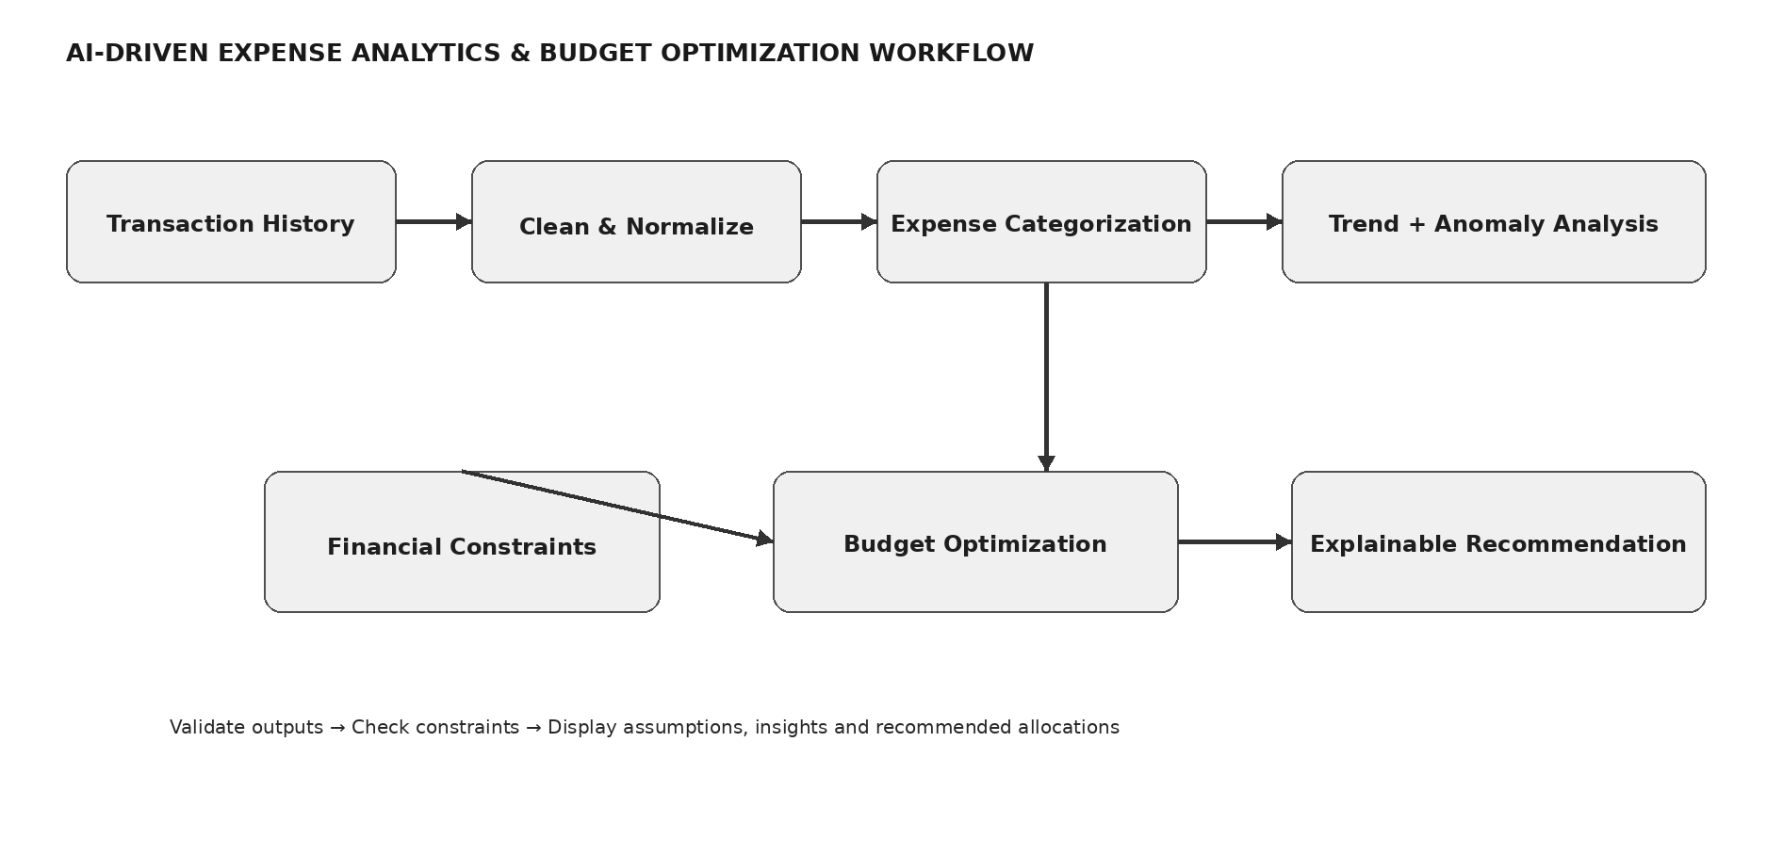

Diagram 3: Expense Analytics and Budget Optimization Workflow

CHAPTER 5

CONCLUSION, FUTURE WORK AND REFLECTION

5.1 Conclusion
This project addressed the engineering problem of building an intelligent personal finance management system for transaction processing, AI-driven expense analytics and budget optimization. The selected solution applies efficient sorting and searching to transaction data, uses explainable analytics to understand spending behaviour and applies constraint-aware optimization to generate a practical budget recommendation. The architecture was selected through an explicit trade-off analysis that considered performance, transparency, reliability, privacy, maintainability and project relevance.
The most important design principle is the separation of concerns. Data processing is responsible for validating and organizing transactions; analytics is responsible for categorization, trends and anomaly detection; optimization is responsible for budget allocation; and the benchmark layer is responsible for measurement. This separation makes the system easier to verify and allows future algorithms or models to be introduced without rewriting the complete application.
Validation should combine correctness tests with analytical and optimization measurements. Correctness establishes that transactions are processed accurately and budget outputs satisfy constraints. Analytics testing establishes whether classifications and anomaly indicators behave as expected. Performance testing establishes whether the expected algorithmic advantage appears as transaction-history size grows. The final submission should insert measured values and screenshots from the actual implementation before claiming quantitative performance.

5.2 Future Work
- Add personalized learning of expense categories using validated user corrections.
- Use incremental and streaming analytics so new transactions can be processed without recomputing the complete history.
- Introduce more advanced anomaly detection using time-series or probabilistic models while retaining explainability.
- Learn budget objective weights from validated user preferences instead of setting them manually.
- Use more scalable indexing, aggregation and approximate analytics for very large transaction histories.
- Integrate secure, consent-based financial-data imports through appropriate APIs in a future production system.
- Introduce stronger authentication, encryption, audit logging, privacy controls and monitoring for deployment beyond the academic prototype.
5.3 Professional Learning & Individual Reflection

New Knowledge Acquired
- Practical application of sorting, searching and boundary testing to transaction datasets.
- Comparison of algorithmic approaches from an engineering trade-off perspective.
- Feature normalization, expense categorization and anomaly scoring for financial analytics.
- Constrained optimization and interpretation of budget-allocation objectives.
- Risk, privacy, security, ethics and reproducibility considerations in software engineering.

Engineering & Professional Skills Developed
- Requirements decomposition and traceability.
- Modular algorithm and analytics implementation.
- Test-case design, validation and result interpretation.
- Technical documentation and IEEE-style referencing.
- Project planning, contribution tracking and evidence-based decision making.

Individual Reflection – Student 1
The most difficult engineering problem was deciding how to combine efficient transaction processing with AI-driven analytics and budget optimization without making the architecture unnecessarily complex. The final decision was to separate the data, analytics and optimization stages so that each could be tested independently. I developed a stronger understanding of algorithmic preconditions and learned that financial recommendations require explicit assumptions and constraints. If the project were repeated, I would establish the benchmark dataset and automated tests earlier.

Individual Reflection – Student 2
The main challenge was preparing consistent transaction records because expense analytics and budgeting depend on reliable dates, amounts and categories. I learned that data validation is part of algorithm engineering, not merely a preprocessing task. A key decision was to define explicit rules for missing values, duplicates and category conflicts. If the project were repeated, I would automate schema validation and generate a larger controlled dataset earlier.

Individual Reflection – Student 3
The most challenging aspect was selecting an analytics approach that remained understandable to the user. I used explicit features and explainable anomaly or categorization logic so that an insight could be traced to transaction attributes. I learned how normalization affects analytical scores and why model outputs should be validated against known examples. If the project were repeated, I would add more sensitivity analysis and validated preference data.

Individual Reflection – Student 4
The main challenge was integrating the analytics and optimization modules while ensuring that the final output remained consistent with the test plan. I learned the importance of defining clear interfaces between transaction loading, analytics, optimization and reporting components. A key decision was to keep timing measurement separate from functional output so that benchmark results could be reproduced. If the project were repeated, I would improve automated regression testing and maintain a clearer experiment log.

REFERENCES
The following references use a consistent IEEE-style numbering approach. The project team should add any additional datasets, software packages, websites or AI-assisted resources actually used during implementation.
[1] T. H. Cormen, C. E. Leiserson, R. L. Rivest and C. Stein, Introduction to Algorithms, 3rd ed. Cambridge, MA, USA: MIT Press, 2009.
[2] D. E. Knuth, The Art of Computer Programming, Vol. 3: Sorting and Searching, 2nd ed. Reading, MA, USA: Addison-Wesley, 1998.
[3] C. A. R. Hoare, “Quicksort,” The Computer Journal, vol. 5, no. 1, pp. 10–16, 1962.
[4] S. Russell and P. Norvig, Artificial Intelligence: A Modern Approach, 4th ed. Hoboken, NJ, USA: Pearson, 2021.
[5] C. M. Bishop, Pattern Recognition and Machine Learning, New York, NY, USA: Springer, 2006.
[6] T. Hastie, R. Tibshirani and J. Friedman, The Elements of Statistical Learning, 2nd ed. New York, NY, USA: Springer, 2009.
[7] S. Boyd and L. Vandenberghe, Convex Optimization, Cambridge, U.K.: Cambridge University Press, 2004.
[8] H. A. Simon, “Theories of bounded rationality,” in Decision and Organization, C. B. McGuire and R. Radner, Eds. Amsterdam, Netherlands: North-Holland, 1972.
[9] Python Software Foundation, Python 3 Documentation, 2026.
[10] ISO/IEC 27001:2022, Information security, cybersecurity and privacy protection — Information security management systems — Requirements, International Organization for Standardization, 2022.
[11] The project team, “Personal finance transaction dataset,” internal academic project dataset, 2026.
[12] The project team, “AI-driven expense analytics and budget optimization prototype,” internal academic project implementation, 2026.
Reference-use note: [1]–[5] support algorithmic design and complexity reasoning; [6]–[9] support analytics, anomaly detection and optimization framing; [10] supports the security-management reference used in the design; [11] supports the Python implementation environment; [12] should be replaced or supplemented with the actual transaction dataset, analytics libraries and other resources used.

APPENDIX A – DETAILED CALCULATIONS

A.1 Binary Search Comparison Bound
For an ordered array of n transaction records, binary search repeatedly replaces the current interval with one half of that interval. After k halvings, the remaining interval is approximately n/2^k. Therefore, k is approximately ceil(log2 n) for the interval to reach one candidate.

A.2 Sorting Complexity
Merge sort satisfies T(n)=2T(n/2)+O(n), which resolves to O(n log n). The linear term arises from merging two sorted halves. Quicksort can be represented as T(n)=T(k)+T(n−k−1)+O(n), with average-case O(n log n) and worst-case O(n²) depending on pivot behaviour.

A.3 Similarity Calculation
For expense analytics, let a and b be normalized transaction-feature vectors. A simple similarity can be defined as S(a,b)=Σw_i s_i(a,b), with w_i≥0 and Σw_i=1. For a bounded numeric feature, s_i(a,b)=1−|a−b|/R_i. For anomaly detection, a transaction can be flagged when its normalized score exceeds a documented threshold or falls outside an expected range.

A.4 Benchmark Measurement
For repeated timing, record t_1,…,t_m. The mean is t̄=(1/m)Σt_j. The sample standard deviation is s=sqrt(Σ(t_j−t̄)^2/(m−1)). Reporting both median and mean is recommended because occasional runtime interruptions can affect individual measurements.

APPENDIX B – ENGINEERING DRAWINGS / SCHEMATICS

Figure B.1. Expanded architecture reference for implementation.

B.1 Search Flow
- Receive user query or dashboard request and select the required finance operation.
- Normalize transaction representation and validate dates, amounts and required fields.
- Select the corresponding sorted index or aggregate structure.
- Perform binary search, aggregation or a controlled no-match result.
- Retrieve matching transaction records or summary data.
- Apply requested sorting, grouping or ranking.
- If analytics is requested, normalize features and compute category, trend or anomaly indicators.
- If budgeting is requested, construct the available-income and constraint model and optimize category allocations.
- Display expense insights, budget allocations, assumptions and result metadata.

B.2 Data Interface
A minimum transaction record should contain transaction_id, date, amount, merchant and category fields, with optional payment_method, account_type and recurring indicators. Optional fields should be explicitly marked as missing rather than silently substituted.

APPENDIX C – SOURCE CODE / CODE REPOSITORY INFORMATION
The complete source code should be maintained in the approved project repository. Only essential excerpts should be inserted into the final report. The following structure is recommended for the finance-management prototype.
- data_loader.py – load and normalize transaction records.
- validator.py – validate required fields, dates, amounts and category values.
- sorter.py – merge sort and/or quicksort implementation.
- search_engine.py – binary-search functions and transaction-key selection.
- expense_analyzer.py – category aggregation, trend analysis and feature generation.
- anomaly_detector.py – unusual-spending detection and scoring.
- budget_optimizer.py – constrained budget-allocation algorithm.
- benchmark.py – repeated timing and result logging.
- tests/ – unit and integration test cases; README.md – setup, execution, dataset description and reproducibility instructions.

C.1 Essential Pseudocode
Binary search: set low=0 and high=n−1; while low≤high, compute mid; compare the transaction key at mid with the query; if equal return the record; if the record key is smaller, move low to mid; otherwise move high to mid−1.
Budget optimization: obtain income and mandatory constraints; define candidate category allocations; evaluate each feasible allocation against the objective; retain the allocation with the highest valid score; return the plan together with constraint checks and explanatory metadata.

C.2 Reproducibility Record
Item | Value to Record
Operating system | [Insert]
Python version | [Insert]
CPU / RAM | [Insert]
Dataset version | [Insert]
Number of transactions | [Insert]
Sort algorithm | Merge sort / quicksort
Search algorithm | Binary search
Analytics method | [Insert]
Optimization method | [Insert]
Benchmark repetitions | [Insert]

APPENDIX F – CAPSTONE PROJECT OUTCOME MAPPING SHEET
Outcome Evidence | SO / Area | Location in This Report
Complex engineering problem formulation | SO1 | Ch. 1, Ch. 2
Engineering design under constraints | SO2 | Ch. 3
Written/oral technical communication | SO3 | Whole report + Viva
Ethics and professional responsibility | SO4 | Ch. 3 (3.7)
Teamwork and leadership | SO5 | Ch. 4 (4.8)
Experimentation, analysis, engineering judgment | SO6 | Ch. 4 (4.3–4.6)
Independent acquisition of new knowledge | SO7 | Ch. 5 (5.3)
Standards | SO2 | Ch. 3 (3.2)
Sustainability and societal/environmental impact | SO2/SO4 | Ch. 3 (3.7)
Risk assessment and mitigation | SO2/SO4 | Ch. 3 (3.7)
Security considerations | Relevant SO | Ch. 3 (3.7)
Integrated/system-level engineering | SO1/SO2 | Ch. 3 (3.5)
Project planning and management | SO5 | Ch. 4 (4.8)
Individual contribution | SO1–SO7 | Contribution Statement + Ch. 4 (4.8)

